Qs 1
L = 1 when A < B
E = 1 when A = B
G = l when A > B

A0 | A1 | B0 | B1 | L | E | G
0 | 0 | 0 | 0 | 0 | 1 | 0
0 | 0 | 0 | 1 | 1 | 0 | 0
0 | 0 | 1 | 0 | 1 | 0 | 0
0 | 0 | 1 | 1 | 1 | 0 | 0
0 | 1 | 0 | 0 | 0 | 0 | 1
0 | 1 | 0 | 1 | 0 | 1 | 0
0 | 1 | 1 | 0 | 1 | 0 | 0
0 | 1 | 1 | 1 | 1 | 0 | 0
1 | 0 | 0 | 0 | 0 | 0 | 1
1 | 0 | 0 | 1 | 0 | 0 | 1
1 | 0 | 1 | 0 | 0 | 1 | 0
1 | 0 | 1 | 1 | 1 | 0 | 0
1 | 1 | 0 | 0 | 0 | 0 | 1
1 | 1 | 0 | 1 | 0 | 0 | 1
1 | 1 | 1 | 0 | 0 | 0 | 1
1 | 1 | 1 | 1 | 0 | 1 | 0

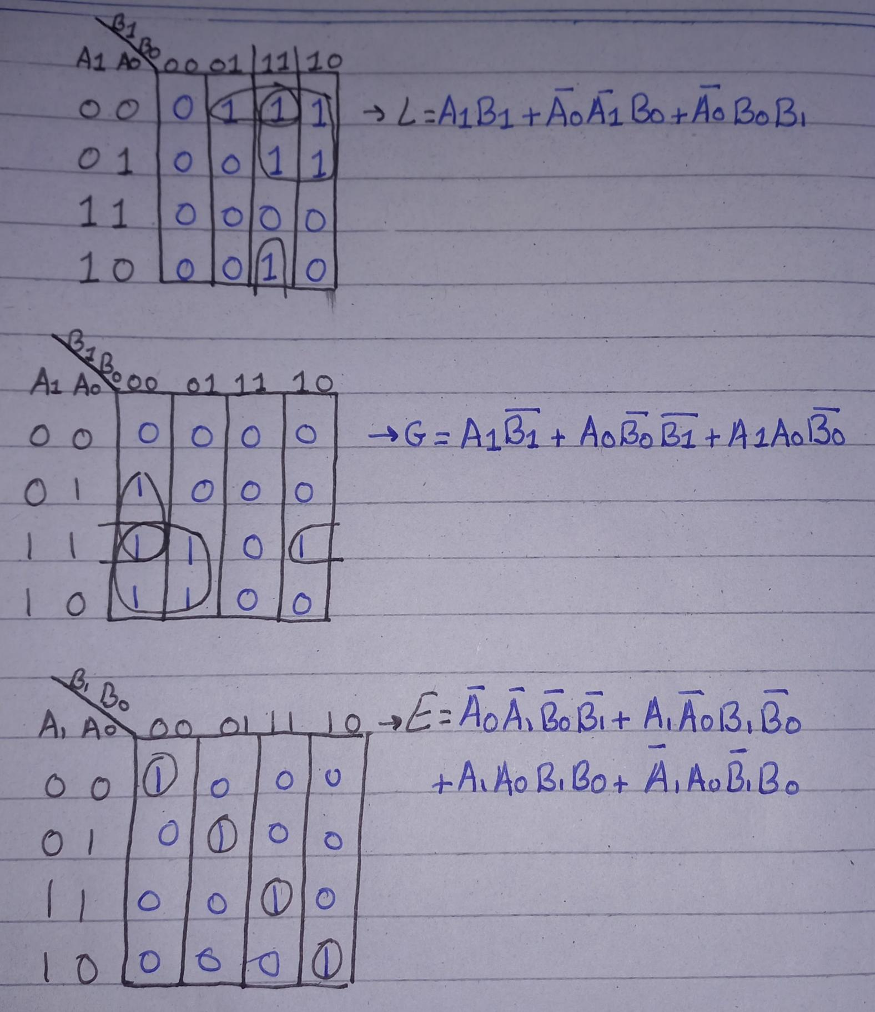
Expressions simplify to
1) (A1​⊕B1​)’(A0​⊕B0​)’+(A1​⊕B1​)(A0​⊕B0​)’ = (A0​⊕B0​)’ (A1​⊕B1​)’ = E
2) A1(B1 + B0) = G
- A1’B1 + A0’B0 = L

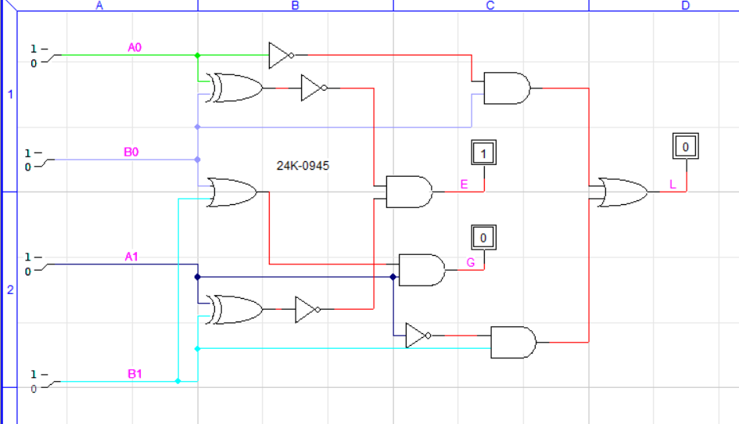

Qs 2

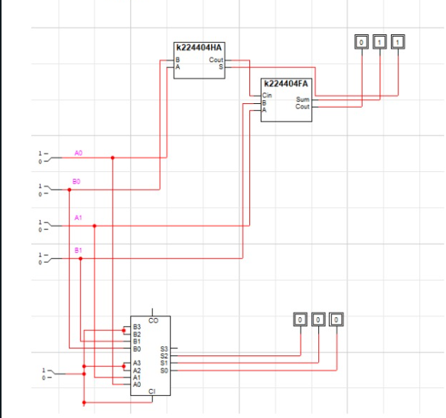

The higher circuit implementation is for the adder, while the lower implementation is for the subtractor of 2 bit.

